**Structure of Bee Communities in Marginal Lands of the Puget Sound, USA**

Evan Sugden1*, Will Peterman2, Robert Redmond3, Riley M. Anderson4, and David W. Crowder4

1 Entomo-Logic, Salt Lake City, UT, USA, ZIP??

2 Bee Search, Seattle, WA, USA, ZIP??

3 The Common Acre, Seattle, WA, USA, ZIP?? (deceased)

4 Department of Entomology, Washington State University, Pullman, WA, 99164

* Correspondence: evan@entomologic.com

**ABSTRACT**

Wild bee communities in urban ecosystems are often challenged by habitat fragmentation and low floral diversity. In such settings, relatively unused land surrounding airports or in power line corridors may support bees, even with small habitat patches. However, relatively long-term surveys of wild bees are lacking for many urban areas such as the Puget Sound region of western Washington State, USA. Here, we conducted wild bee surveys at three peri-urban sites in the Puget Sound over a period of 7 years. Specifically, a standardized protocol was used to sample wild bee communities monthly from April to October at two sites associated with airports and one site in a power line corridor. In total, our surveys collected 25,441 specimens representing 118 confirmed species within 24 genera, with individual sites having between 15 and 35 species in any given year. The Halictidae had the most individuals collected, with 47% of specimens, *Lasioglossum* the most speciose, and *Bombus*, *Osmia*, and *Andrena* also ubiquitous and diverse. Bee diversity was high across spring and summer, and the phenology of parasitic taxa appeared to overlap with their hosts. Our study suggests marginal lands requiring little management can support diverse wild bee communities in urban areas. Our work also provides a baseline for future evaluations of wild bee communities in the Puget Sound and broader Pacific Northwest.

**Keywords:** Airport, conservation, fragmented landscapes, restoration, pollinators, power line corridor, urban ecosystems

**INTRODUCTION**

Wild bee communities are impacted by abiotic conditions as well as availability of nectar, pollen, and nesting resources (REFS). As natural habitats are lost to urbanization and agriculture, bees lose resources, leading to population declines (REFS). Yet, not all wild bee species are equally impacted by alterations of habitat, including restoration efforts on degraded lands (REFS). To aid pollinator assessment and conservation, studies are needed to assess how different forms of habitat restoration impact bee community structure. Given that the dynamics of bee communities and their local floral resources can be highly ephemeral, capturing temporal trends within and across seasons may be particularly valuable (Bloom et al. 2023). Such studies can also provide a baseline of species diversity and abundance to guide future evaluations.

SPACE FOR REFS

Urban and peri-urban habitats present unique challenges for bees due to the large amount of impervious surface, which eliminates ground-nesting, combined with extreme fragmentation of resources (REFS). Efforts to restore bee communities in urban areas has taken many forms, such as the restoration of urban lots into pollinator-friendly spaces with diverse native flowering plants that provide continuous food resources (REFS). Government-leased lands, such as parks and utility corridors, can also be used for pollinator meadows, which not only increases floral diversity but also establish nesting substrates that are key for solitary bees (REFS). Specific practices, like minimizing lawn mowing or incorporating green roofs, improve habitat quality while enhancing ecological connectivity in fragmented urban landscapes (Turo & Gardiner, 2019). By leveraging government land for habitat restoration, cities can create interconnected networks of pollinator refuges, fostering urban biodiversity and ecological resilience.

SPACE FOR REFS

Efforts to restore bee habitat in urban areas have recently focused on restoration of airports, with Chicago O’Hare, Detroit Metropolitan, and Seattle-Tacoma Airport examples of sites that have turned underused land into bee habitat (REFS). There is often considerable land around airports given the need for undeveloped space for planes, and land that was formerly used for airports that have been de-commissioned may also provide habitat. However, it is unclear how restoration of airports may affect different bees that vary in seasonality and resource requirements. Further, understanding how restored airports compare to other habitats is key to determine if restorations can support diverse and robust bee communities (REFS). These knowledge gaps highlight the need for continued research to refine habitat restoration strategies and maximize their effectiveness in both airport environments and broader urban landscapes.

SPACE FOR REFERENCES

Our study evaluated the diversity and structure of wild bee communities in marginal lands of western Washington State, USA. Bee diversity of western Washington has remained largely undescribed, except for a few recent studies on farm, garden, and parkland habitat (Bloom et al. 2021, 2023). Given the rapid urbanization of western Washington, assessments are needed to determine the status of common and rare species. To address this, we conducted monitoring over seven years at three sites in western Washington, two on airports and one that used government-leased land in power corridors. Our focus was to document the bee community structure in the study areas and the temporal dynamics of each species. We also assessed how bee communities varied within and across seasons. Our study provides a baseline for future evaluations of bee communities in western Washington and insight into whether restoration of government-leased airport and land beneath power lines can support robust and diverse bee communities.

**METHODS**

***Study System***

Our surveys of wild bees were conducted at three sites in the lower Puget Sound region in western Washington State, within a few miles of the major cities of Seattle (two sites) or Everett (one site). Although sites were unique, they were similar in their proximity to development, past history of disturbance, and largely weedy nature of the vegetation. The three sites and the years monitored were: (i) Port of Seattle (SeaTac Airport) (2014-2020), (ii) Boeing Paine Field (airport facility) (2018-2020), and (iii) Seattle City Light (power corridor) (2016-2018). Our surveys assessed the diversity and community structure of wild bees within and across seasons.

***Study Site Descriptions***

The Port of Seattle site is 3 km south of the airport runways on land serving as a security buffer zone. In the mid-20th century it was also used as a golf course, components of which are still recognizable (e.g., sand traps). The vegetation is varied and weedy, with patches of past revegetation, wild Himalayan blackberry (*Rubus aermeniacus*), knapweed (*Centaurea* sp.), wild mustard (*Brassica* spp.), and big leaf maple (*Acer macrophyllum*) common species. Open areas with low perennial or annual weedy plants provided the main collecting habitat. Trap sites were separated by a few hundred meters, and two apiaries with up to 10 colonies within 1 km.

Boeing Paine Field is 10 km SW of Everett, WA. Habitat included low-maintenance lawn and meadow to riparian, all surrounded by a narrow corridor of red alder (*Alnus rubra*). Beyond the site, the landscape is composed mainly of suburban development and airport parking lots and runways. This site is 1 km from the Puget Sound and experiences maritime influence. This site, trapped from 2018-2020, consisted of 5 stations with separations of between 50 and 500 m.

The Seattle City Light site is a power corridor 10 km southeast of Seattle, and consisted of 5 trap stations 2 km apart: (i) a semi-managed meadow- habitat in Rainier Beach neighborhood, (ii) a semi-boggy slope descending toward the interstate, (iii) the bounds of a weedy equipment storage pad North of the Duwamish Hill Preserve, (iv) the banks of the Duwamish River between a road and a power transfer facility, and (v) a site near a power station (only sampled in 2016).

***Bee Surveys***

Trap stations consisted of uniform linear arrays of 15, 15-cm plastic Solo cups, placed in 5 clusters of 3 each; each cluster had one blue, one yellow, and one white cup. These large cups were replaced in 2016 with identically-painted 4 oz. “mini-cups”. The cups were accompanied by 3 equally-spaced “blue vane” traps (BanfieldBio, Woodinville, WA) with original fluorescent yellow jars. However, due to the potential presence of the threatened *Bombus occidentalis* at the Boeing Paine Field site, we only used one blue vane trap per array. Traps were placed at each site once per month from April to September, with arrays placed between 08:00 and 10:00 and left for 24 hours before collection. Trap collecting was supplemented with net collecting on an opportunistic basis (Turley et al. 2024). The method used was sweeping with a heavy 15-inch sweep net bag and the standard measurement of effort consisting of 100 sweeps.

Specimens from traps were removed by pouring the trap fluid through a fine strainer and placing bees into vials filled with 70% ethanol; net-collected specimens were dispatched with ethyl acetate and placed in blotter paper “layers” for storage. In the laboratory, specimens were then removed from alcohol and grouped taxonomically to the lowest level allowing certainty of identification to species or morphospecies, and sex was recorded when possible. Specimens were identified using published taxonomic papers, semi-technical guides, and online Discover Life keys. When we were unable to identify specimens ourselves professional assistance was sought from a number of specialists by sending them representative samples, or through personal visits to the USDA Pollinating Insects/Utah State University Bee Collection in Logan, UT to use the extensive collection there and consult directly with resident specialists. Similar help was also sought at the Bohart Museum of Entomology, University of California, Davis, CA. Specimens that eluded species identity were assigned morphospecies classifications that were unique.

***Analytics***

All analyses were performed in R version 4.2.3 (R Core Team, 2023) and all figures and data wrangling used the *tidyverse* ecosystem of packages (Wickham et al. 2019). All analyses involving species counts were restricted to records with confirmed identification. That is, all records identified to morphospecies, or genus only were excluded when examining species counts. To determine richness saturation in our sampling, we derived species accumulation curves from permutation resampling of the subsites within years for 1) all sites with net and trap collected records, 2) all sites with trap records, 3) trap records from Port of Seattle, 4) trap records from Boeing Paine Field, and 5) trap records from Seattle City Light using the R package, *vegan* version 2.6-6.1 (Oksanen et al. 2024). Preliminary analyses showed a lack of saturation (curves did not reach asymptote), therefore, we elected to estimate minimum richness following Chao et al. (2009).

To compare bee community composition across collection techniques we visualized the proportional abundance and count of unique species within each genus across all years for 1) trap and net collected records from all sites, 2) trap records from all sites, and 3) net records from all sites. Similarly, we compared community composition across the three sites using trap records across all years. Further, to quantitatively describe the differences in species composition across sites, we modeled a matrix of species abundance and subsite/year combinations as a function of the three sites using a permutation MANOVA with *vegan*::*adonis2* (Oksanen et al. 2024). Site location across community composition space was visualized by plotting the first two axes of a three-dimensional NMDS ordination (stress = 0.10) with *vegan*::*metaMDS* (Faith et al. 1987). Finally, we used a random forest model (Breiman 2001) to define the species most representative of the compositional differences in sites following similar methods in Anderson et al. (2024). Briefly, we constructed a classification model with site as the response variable and the matrix of species abundance across subsites and years as the predictor variables. We then selected the top 10th percentile of species based on variable importance score using *randomForest*::*varImp* (Liaw & Wiener 2002).

To assess the seasonal biology of bee communities at the genus and species level, we used kernel density estimation and the *ggridges* package (Wilke 2024). First, we aggregated genus and species counts over weekly intervals summed across years and sites. For genus-level density estimation, we used biased cross validation to select the smoothing parameter individually for each genus (Scott 1992). Importantly, genus-level comparisons likely include multiple species with potentially non-overlapping phenologies, therefore, this nonparametric smoother avoids making assumptions about the underlying distribution and allows for multimodality. For species-level density estimation, we used Silverman’s smoothing method which assumes a Gaussian distribution.

R Core Team (2023). R: A language and environment for statistical computing. R Foundation for Statistical Computing, Vienna, Austria. URL <https://www.R-project.org/>.

Wickham H, Averick M, Bryan J, Chang W, McGowan LD, François R, Grolemund G, Hayes A, Henry L, Hester J, Kuhn M, Pedersen TL, Miller E, Bache SM, Müller K, Ooms J, Robinson D, Seidel DP, Spinu V, Takahashi K, Vaughan D, Wilke C, Woo K, Yutani H (2019). Welcome to the tidyverse. *Journal of Open Source Software*, **4**(43), 1686. doi:10.21105/joss.01686.

Oksanen J, Simpson G, Blanchet F, Kindt R, Legendre P, Minchin P, O'Hara R, Solymos P, Stevens M, Szoecs E, Wagner H, Barbour M, Bedward M, Bolker B, Borcard D, Carvalho G, Chirico M, De Caceres M, Durand S, Evangelista H, FitzJohn R, Friendly M, Furneaux B, Hannigan G, Hill M, Lahti L, McGlinn D, Ouellette M, Ribeiro Cunha E, Smith T, Stier A, Ter Braak C, Weedon J (2024). vegan: Community Ecology Package. R package version 2.6-6.1, https://CRAN.R-project.org/package=vegan.

Chao, A., Colwell, R. K., Lin, C.-W., & Gotelli, N. J. (2009). Sufficient Sampling for Asymptotic Minimum Species Richness Estimators. *Ecology (Durham)*, *90*(4), 1125–1133. https://doi.org/10.1890/07-2147.1

Faith, D. P, Minchin, P. R. and Belbin, L. (1987). Compositional dissimilarity as a robust measure of ecological distance. *Vegetatio* 69, 57–68.

Breiman, L. (2001), *Random Forests*, Machine Learning 45(1), 5-32.

Anderson, R. M., Hennessy, A. B., Kowalski, K., Kessler, A., Bagchi. R., & Singer, M. S. (2024). Phloem-feeding insects create parasitoid-free space for caterpillars. *Current Biology* 34(16). https://doi.org/10.1016/j.cub.2024.06.074

A. Liaw and M. Wiener (2002). Classification and Regression by randomForest. R News 2(3), 18-22.

Wilke, C. (2024). ggridges: Ridgeline Plots in 'ggplot2'. R package version 0.5.6, https://CRAN.R-project.org/package=ggridges.

Scott, D. W. (1992) *Multivariate Density Estimation: Theory, Practice, and Visualization.* New York: Wiley.

**RESULTS**

***Bee community structure***

Across the three sites and seven years of the project we collected 25,441 bee specimens. Of these, 25,017 (98.3%) were identified to species, representing 118 species from five families and 24 genera. Of the remaining 424 specimens, 376 (1.48%) were identified to morphospecies, representing potentially 35 additional species within the genera *Nomada*, *Osmia*, *Sphecodes*, and *Triepeolus*. The remaining 48 specimens (0.19%) were damaged and only identified to genus.

Our species accumulation curves did not reach asymptotes, suggesting the 118 confirmed species is likely an underestimate of the true richness across the sites (Fig. 1A). Chao richness estimation suggests the minimum richness across all sites and years was 139 species (using trap and net collected records). Using only trap records, Chao richness was estimated at 124 species. Chao richness for the individual sites, Port of Seattle, Boeing Paine Field, and Seattle City Light was estimated using trap records only at 115, 80, and 92 species, respectively. Within individual years, each site had between 15 and 40 identified species, with an estimated Chao minimum richness of between 35 and 70 species (Fig. 1B). These estimates suggest that in any year we potentially captured only between 30 and 70% of the total species richness present at each site. Our results also show that not all species were present in every year, and only by collecting over multiple years did we gain a better estimate of the total diversity of the bee community (Fig. 1).

Species represented by a single specimen have a disproportionate effect on analyses such as Chao richness and may have special importance regarding conservation and biogeography. Twenty of our species (17.0% of total) were represented by only a single specimen (Table S1). In contrast, certain species were abundant, with one having 11,787 specimens (*Halictus tripartitus*), three with over 1,000 specimens, and five with at least 500 specimens; the ten most abundant species reflected 7 genera (Table S2). Moreover, 51 species across 15 genera were found at all three sites (Table S3). We also found that collecting technique was non-negligible, with 11 total species collected only by net, representing 9.3% of total richness (Table S4). As males are often underrepresented in collections we also list species for which we collected no males (Table S5). We collected a total of 575 *Apis mellifera*, representing 2.26% of total specimens; of these, 213 were collected by net with the remainder mostly caught in blue vane traps (Table S6).

Across all sites and years, the distribution of specimens across taxa was highly uneven, with 47.0% of total individuals in the genus *Halictus* (Fig. 2A). This may in part also reflect greater sampling effort at the Port of Seattle, where *Halictus* was dominant (Fig. 2D), compared to the Boeing Paine Field and Seattle City Light sites, where Bombus was the most common taxa (42.8% and 26.1%, respectively) (Figs. 2E, 2F). Although *Halictus* and *Bombus* were most abundant, *Lasioglossum*, *Andrena*, *Osmia*, and *Megachile* were far more speciose (Fig. 2). However, in general similar species were found at all of the sites, indicating that diversity was relatively conserved at the genus level across sites.

Species composition varied significantly across sites (PERMANOVA; *F*2 = 2.11, *P* = 0.005), with Boeing Paine Field hosting a statistically distinct bee community from the Port of Seattle and Seattle City Light sites (Fig. 3). Major changes in abundance primarily delineated the Boeing Paine Field site from the others. Notably, when compared to Port of Seattle and Seattle City Light sites, the Boeing Paine Field site had drastic reductions in *H. tripartitus*, *Agapostemon texanus*, *A. mellifera*, and *Bombus fervidus*, and increases in *Bombus melanopygus*, *Halictus confusus*, and *Bombus mixtus* (Table 1). Moreover, our random forest model classified each site by species composition with an overall error rate of 15.4%. Error in the model is attributed to the overlap in species composition in Port of Seattle and Seattle City Light sites. However, the Boeing Paine Field site was never misclassified (0.0% class error), showing that the Boeing Paine Field site was quantitatively different from the others in terms of species composition.

***Bee seasonal biology***

We assessed the seasonal biology of bee genera (Fig. 4) and species (Fig. 5). The first bees to emerge were species in the genera *Ceratina*, *Andrena*, and *Nomada*; however, while *Andrena* and *Nomada* peaked in early spring, *Ceratina* was found across the entire season (Figs. 4, 5). The genera *Osmia* and *Lasioglossum* also peaked in spring but had a short activity period (Figs. 4, 5). Other genera peaked in summer months, including *Apis*, *Bombus*, *Halictus*,  *Hylaeus*, *Megachile*, *Melissodes*, and Sphecodes (Figs. 4, 5). For genera, multimodal distributions likely represent multiple species, as well-defined multimodality was rare at the species level, with most species reaching a single peak abundance before tapering off. Small peaks observed in distributions may also arise from structured sampling events rather than true biological phenomena. Yet, given that major peaks in abundance are detectable despite the sampling noise suggests our data capture the true seasonal maxima of these species. When focusing on the entire community, our results show that substantial turnover occurs within seasons, but diverse communities exist across the year.

When looking at common parasitic genera, we found major overlap in phenology with their presumed hosts (Figs. 6, S1). For example, *Nomada* parasites peaked in the spring at a similar time as their hosts *Andrena* and *Agapostemon* (Fig. 6A), and *Coelioxys* parasites peaked in summer at the same time as their *Megachile* hosts (Fig. 6C). However, while *Sphecodes* strongly overlapped with *Halictus*, two other presumed hosts (*Agapostemon* and *Lasioglossum*) tended to be active earlier in the season (Fig. 6B). Although we did not have enough specimens to reliably estimate the phenology of three other parasites (*Stelis*, *Epeolus*, *Triepeolus*), preliminary estimates of overlap between these species and their presumed hosts are shown in Fig. S1.

**DISCUSSION**

Our study shows a diverse community of wild bees persists in relatively marginal habitats of the lowland Puget Sound region of western Washington State, USA. We captured a total of 118 species across 24 genera, which exceeds the 75 species across 21 genera found in recent surveys of western Washington diversified farms and gardens (Bloom et al. 2019, 2022, 2023). Notably, our study identified an additional 35 morphospecies, suggesting we may have found as many as 153 species, while Bloom et al. (2022) identified 34 morphospecies, suggesting a total community with as many as 109 species. Although the genera captured across both studies were largely consistent, we likely found more species due to our monthly sampling that spanned April to October compared to sampling three times a year (Bloom et al. 2022). It is also possible that the greater number of species found in our sites reflected largely weedy compared to managed floral communities, or because management of farm sites may have limited floral resources for bees. We also note that on diversified farms and gardens Bloom et al. (2019, 2022, 2023) found that 47% of their total specimens were *A. mellifera*, while we found less than 3%. These results suggest that marginal lands may provide considerable habitat for wild bees that offers limited competition from honey bees, especially when compared to nearby managed farms and gardens.

Our study provides evidence that land around airports and below power line corridors can support diverse wild bee communities. These often underused spaces thus provide an opportunity to support biodiversity while minimally interfering with the function of the land. Airports often have extensive grassy perimeters, and restoring native plants to these areas, or reducing mowing and allowing native plants to proliferate, may create suitable habitat for bees (Linz et al., 2021; Gallé et al., 2022). Similarly, power line corridors are often cleared of large vegetation, and with little maintenance can be used to support bees (Wojcik & Buchmann, 2012; Russell et al., 2018). These efforts may enhance pollination services for nearby green spaces and urban farms while also promoting community development goals (Rundlöf et al., 2015; Hall et al., 2017). Our results provide further evidence that marginal lands may provide a key tool for urban pollinator restoration, especially given that little to no maintenance on the land is required.

Efforts to conserve bees in fragmented urban landscapes extend beyond airports and power lines. For example, community gardens provide a diverse range of flowering plants throughout seasons and often support diverse pollinator communities (REFS). Vacant lots in urban areas can also be managed to support pollinators by creating nesting sites and floral resources through low-maintenance landscaping (REFS). These interventions not only provide forage and shelter for pollinators but also contribute to community engagement. Similarly, by reducing mowing in roadside verges, cities can connect fragmented green spaces, facilitating bee movement and population growth. Our study further suggests that allowing spontaneous vegetation growth in small urban areas supports pollinator diversity by offering a variety of flowering plants and nesting habitat.

Our results shows diverse communities of bees were present across the season, although composition of communities changed over time. The phenology of bee species can be impacted by many factors such as life history, climate niche, and ecological interactions. Similar to other studies, we show that bees such as *Nomada* and *Andrena* are the first to emerge in early spring, aligning with flowering of early-blooming plants (REFS). As the season progresses, the activity of more heat-tolerant genera such as *Halictus* and *Lasioglossum* become more prominent (REFS). In contrast, large-bodied genera like *Apis and Bombus* show prolonged activity, maintaining their colonies throughout the entire growing season, likely by exploiting a wider variety of floral resources (REFS). Our study provides a better understanding of the phenology of bees in the Puget Sound, and future work should consider how these patterns overlap with flowering plant phenology.

Our study also revealed phenology of parasitic bee groups and their hosts, although data was sparse for several taxa. Parasitic taxa such as *Nomada* and *Coelioxys* rely on phenological synchronization with their hosts to ensure access to nests and brood for parasitism. For example, *Nomada* often parasitizes *Andrena* bees, which emerge in early spring, whereas *Coelioxys* may target *Megachile* bees active during late spring and summer (REFS). Despite the ecological importance of these interactions, data on parasitic bees are limited. Many parasitic bees are less abundant than their hosts, and their cryptic behavior makes them hard to observe. Enhanced monitoring, targeted ecological studies, and integration of parasitic bees into broader pollinator research are essential to fill knowledge gaps on the roles of these key species.

CONCLUSION

**ACKNOWLEDGEMENTS**

We thank T. Griswold, H. Ikerd, D. Cox-Foster, J. Strange, J. Gibbs, G. Gardner, R. Thorp, and K. Koyamatsu for assisting in specimen identification, and C. Looney, E. Rare, A. Rinard, N. Mengist, and T. London for logistical support. Field site access was provided by Seattle City Light, The Port of Seattle, and Boeing Corp. Funding was provided by the Bullitt Foundation. We would like to recognize our junior author and colleague, Robert Redmond, now deceased, for his creative vision and facilitation, without which this work would not have been possible.

**LITERATURE CITED**

Aizen MA, Feinsinger P (1994) Habitat fragmentation, native insect pollinators, and feral honey bees in Argentine ‘Chaco Serrano’. Ecol Applications 4:378–392

Bloom, EH, EC Oeller, RL Olsson, MR Brousil, RM Schaeffer, S Basu, Z Fu, DW Crowder. 2022. Documenting pollinators, floral hosts, and plant–pollinator interactions in U.S. Pacific Northwest agroecosystems. Ecology 103:e3606.

Bloom, EH, JG Illan, MR Brousil, JP Reganold, TD Northfield, DW Crowder. 2023. Long-term organic farming and floral diversity promotes stability of bee communities in agroecosystems. Func. Ecol. 00:1-17.

Droege, S. 2006. Impact of color and size of bowl trap on numbers of bees captured.

Droege, S., J. D. Engler, E. A. Sellers, and L. O’Brien. 2017. U.S. national protocol framework for the inventory and monitoring of bees. Second edition. U.S. Fish and Wildlife Service, Fort Collins, Colorado, USA.

Droege, S., and J. Guldin. 2011. Results of a pilot native bee monitoring program using arrays of coloured cup traps filled with propylene glycol. USDA Forest/USGS Project.

Frankie et al 2013 (cited in Prendergast et al 2022)

Griswold, T. and V. Tepedino. 1980. Bees of the Columbia Basin.

Leong JM, Thorp RW (1999) Colour-coded sampling: the pan trap colour preferences of oligolectic and nonoligolectic bees associated with a vernal pool plant. Ecol Entomol 24:329–335.

Lowenstein et al 2019 (cited in Prendergast et al 2022)

Potts SG, Vulliamy B, Dafni A, et al (2003) Linking bees andflower: how do floral communities structure pollinator communities? Ecology 84:2628–2642.

Prendergast, KS, Menz, MHM, Dixon, KW, Bateman, P. The relative performance of sampling methods for native bees: an empirical test and review of the literature. 2020. Ecosphere 11(5):e03076. 10.1002/ecs2. 3076.

Prendergast, KS, Dixon, KW, Bateman, PW. 2022. A global review of determinants of native bee assemblages in urbanised landscapes. Insect Cons. Div. Volume 15, Issue 4. Pp 385-405.

Toler TR, Evans EW, Tepedino VJ (2005) Pan-trapping for bees (Hymenoptera: Apiformes) in Utah’s Desert: the importance of color diversity. Pan-Pacific Entomologist 81:103–113

Turley, NE, Kania, SE, Petitta, IR, Otruba, EA, Biddinger, DJ, Butzler, TM, Sesler, VV, López-Uribe, MM. Bee monitoring by community scientists: comparing a collections-based program with iNaturalist. 2024. Annals of the Entomological Society of America, Volume 117, Issue 4. Pp 220–233. <https://doi.org/10.1093/aesa/saae014>

Williams NM, Minckley RL, Silveira FA. 2001. Variation in native bee faunas and its implications for detecting community changes. Conserv Biol 5:U57–U86.

Winfree R, Griswold T, Kremen C (2007) Effect of human disturbanceon bee communities in a forested ecosystem. Conserv Biol 21:213–223.

Zurbuchen A, Landert L, Klaiber J, Muller A, Hein S, Dorn S. 2010 Maximum foraging ranges in solitary bees: only a few individuals have the capability to cover long foraging distances. Biol Conserv 143:669–676.

**Table 1.** The top 10th percentile of species ranked by variable importance score (mean decrease in Gini) from a random forest classification of site by species composition. The proportional abundance (%) of each species is listed for each site, Port of Seattle (POS), Boeing Paine Field (BPF), and Seattle City Light (SCF). In parentheses are counts of each species. Mean decrease in accuracy is the permuted decrease in model accuracy by removing each species; mean decrease in Gini is the total decrease in node impurities from splitting each node on each species over all trees. In both cases, a larger value indicates greater variable importance in the model’s ability to correctly classify sites by the parameters, in this case, a matrix of species composition.

|  |  |  |  |  |  |
| --- | --- | --- | --- | --- | --- |
| **Species** | **BPF** | **POS** | **SCL** | **µ ↓ Accuracy** | **µ ↓ Gini** |
| *Halictus tripartitus* | 2.1 (38) | 54.3 (11,603) | 7.8 (146) | 12.93 | 3.44 |
| *Agapostemon texanus* | 1.3 (24) | 10.6 (2,269) | 14.7 (275) | 10.85 | 2.76 |
| *Bombus melanopygus* | 5 (89) | 0.1 (23) | 0.1 (2) | 8.66 | 1.8 |
| *Osmia albolateralis* | 0.1 (2) | 1.0 (204) | 0.5 (9) | 7.94 | 1.64 |
| *Apis mellifera* | 0.4 (8) | 2.1 (444) | 6.6 (123) | 7.62 | 1.62 |
| *Melissodes rivalis* | 1.8 (32) | 0.1 (17) | 1.5 (28) | 7.53 | 1.61 |
| *Halictus confusus* | 5.4 (97) | 0.5 (108) | 0.2 (3) | 7.62 | 1.41 |
| *Bombus fervidus* | 0.5 (9) | 0.9 (196) | 2.7 (51) | 6.88 | 1.31 |
| *Bombus vosnesenskii* | 13.9 (248) | 7.3 (1,556) | 18.4 (344) | 6.57 | 1.16 |
| *Bombus mixtus* | 7.6 (135) | 2 (433) | 2.7 (51) | 2.97 | 0.93 |

**FIGURE LEGENDS**

**Fig. 1.** (A) Species accumulation curves for (i) all sites with traps and nets combined, (ii) all sites with traps only, (iii) Port of Seattle (POS); (iv) Boeing Paine Field (BPF), and (v) Seattle City Light (SCL). Trap effort is derived from a permutation resample of the sampling sites across years. Curves are a function of mean permuted richness by sampling effort, shaded regions are 95% confidence intervals, and dotted horizontal segments indicate Chao estimated richness. (B) Species richness for each site; triangles are raw species counts for the subsites and circles are Chao estimated richness for each site within a year; the data exclude morphospecies.

**Fig. 2.** Proportional abundance and unique species for all genera, with (A) trap and net caught records from all sites and years, (B) trap records from all sites and years, (C) net records from all sites and years, (D) trap records from Port of Seattle, (E) trap records from Boeing Paine Field, and (F) trap records from Seattle City Light.The top three panels compare overall composition by collection method, while the bottom three panels compare composition by site. Data exclude morphospecies.

**Fig. 3.** Variation in community composition across sites.Bee species are plotted on the first two axes of a three-dimensional non-metric multidimensional ordination plot. Small points are individual subsite/year combinations. Large points are the centroids of the three sites, and ellipses are 95% confidence intervals around centroids. Bee species shown are the most representative (top 10th percentile) of the compositional differences among sites. Text size of labels is proportional to variable importance score (Table 1).

**Fig. 4.** Genus-level seasonal distributions. Sample sizes are listed, and only genera with sample sizes 20 are shown. Vertical dashed lines correspond to 21 March, 21 June, and 21 September.

**Fig. 5.** Species-level seasonal distributions. Sample sizes are listed, and only species with sample sizes [\ge](https://camo.githubusercontent.com/c2d96728cd1cda8c7998418bbaf71dacc073bf4fbad71ceb03065377d8251e2e/68747470733a2f2f6c617465782e636f6465636f67732e636f6d2f706e672e6c617465783f2535436765) 20 are shown. Vertical dashed lines correspond to 21 March, 21 June, and 21 September.

**Fig. 6.** Seasonal distributions for parasites: (A) Nomada, (B) Sphecodes, and (C) Coelioxys. Beneath each parasite genera are presumed host genera. Sample sizes are the total records for each genus. Vertical dashed lines correspond to 21 March, 21 June, and 21 September.

**Fig. 1**

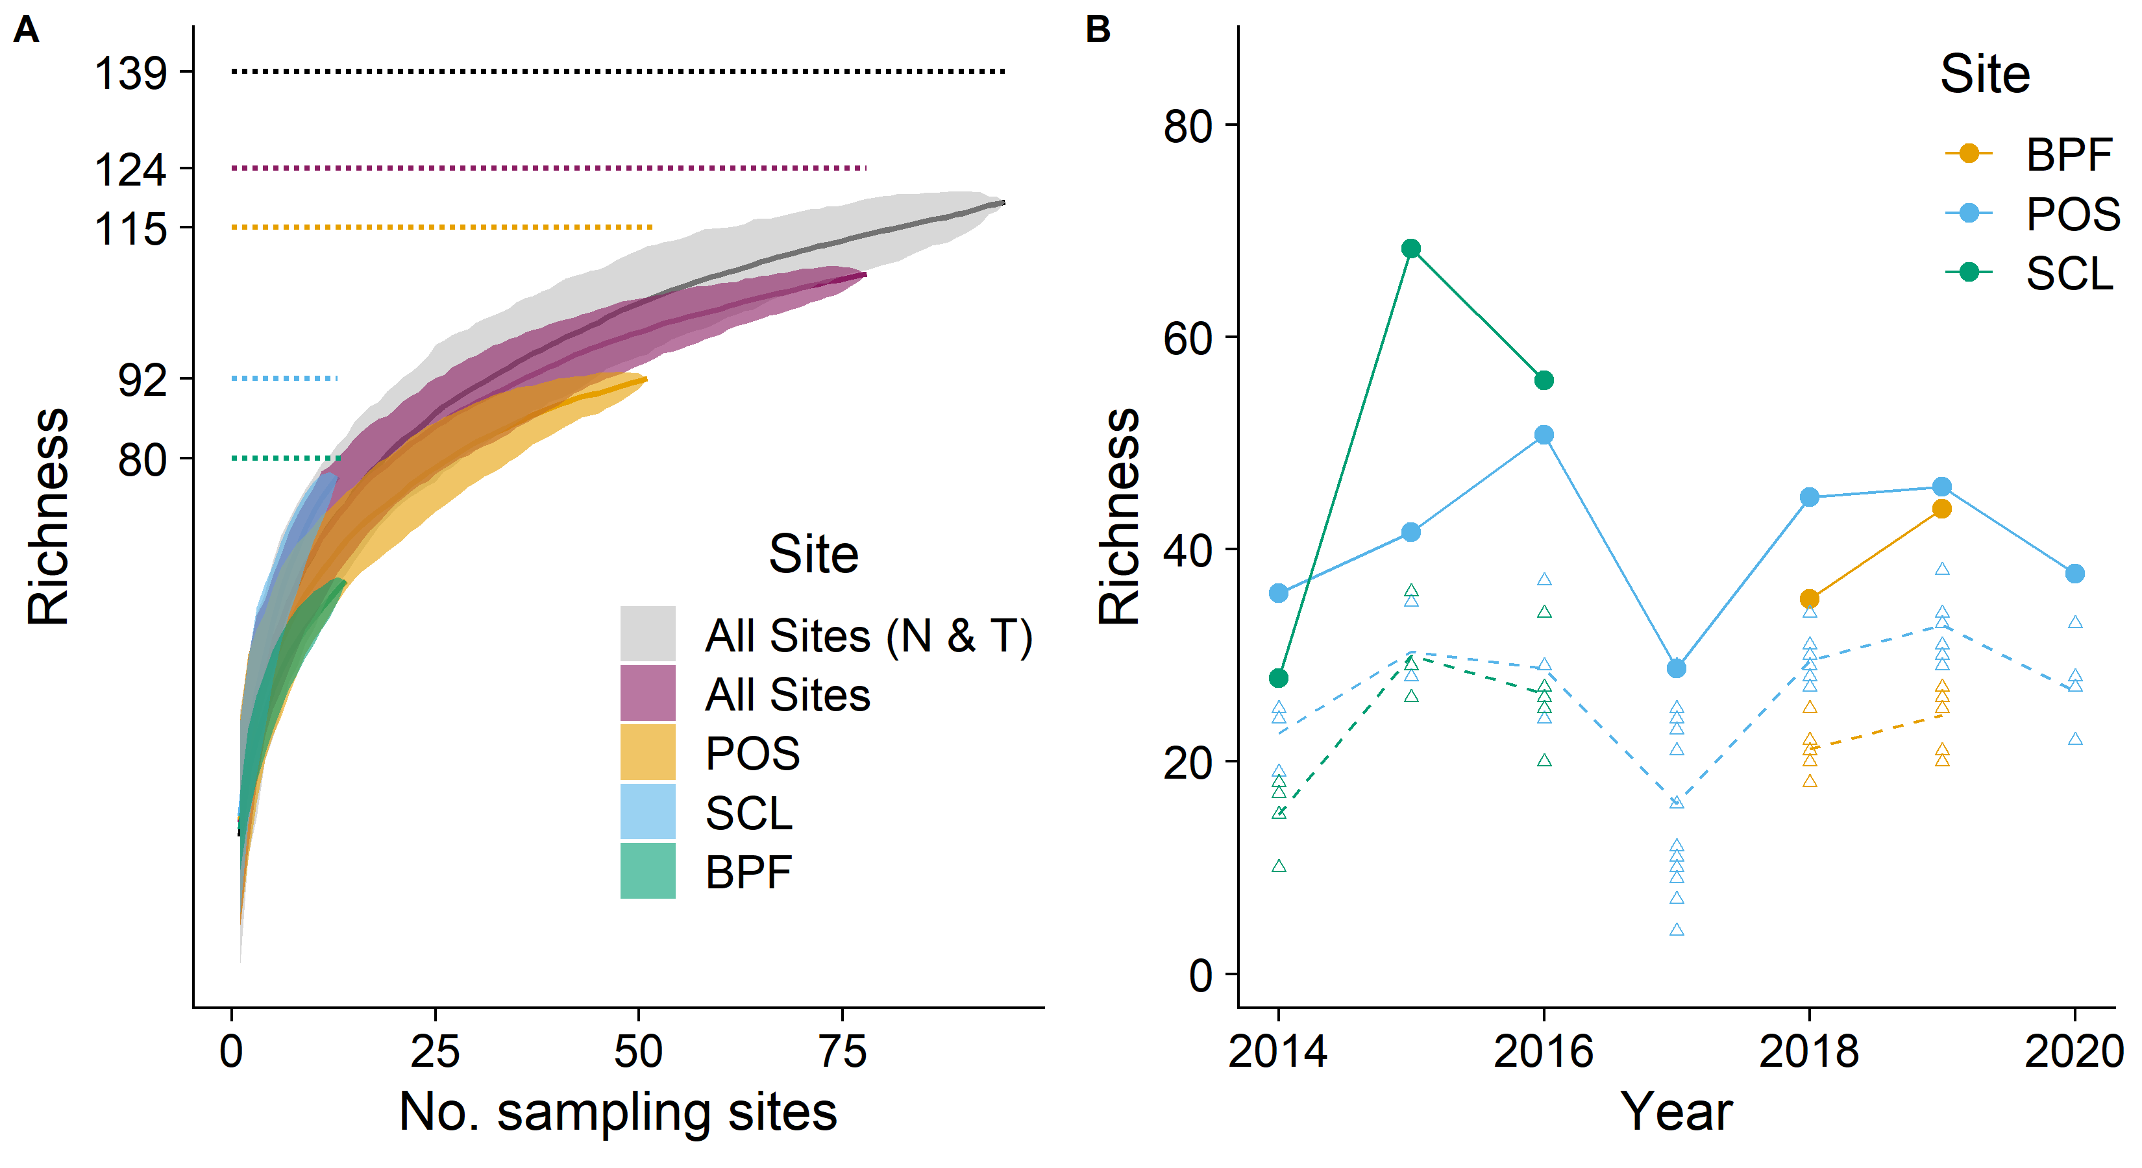

**Fig. 2**

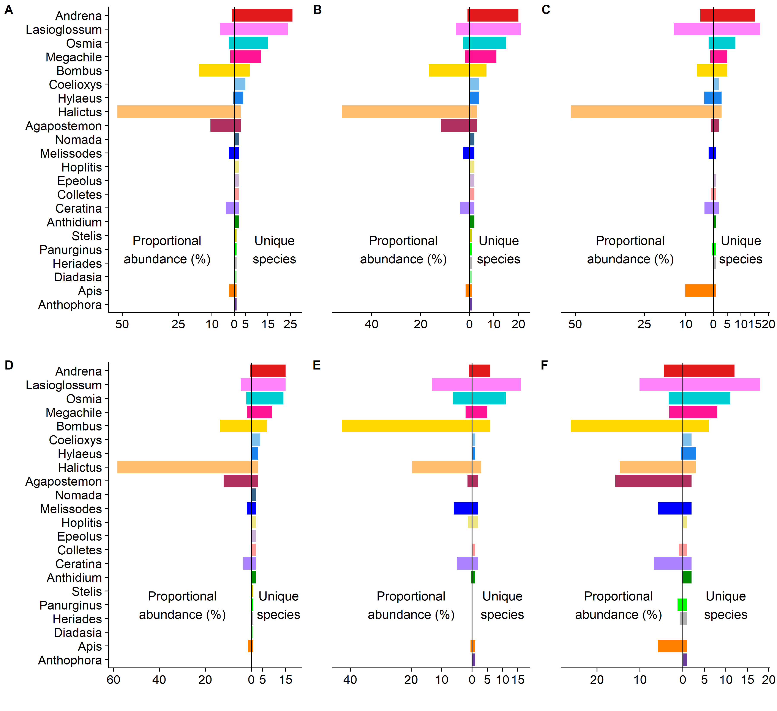

**Fig. 3**

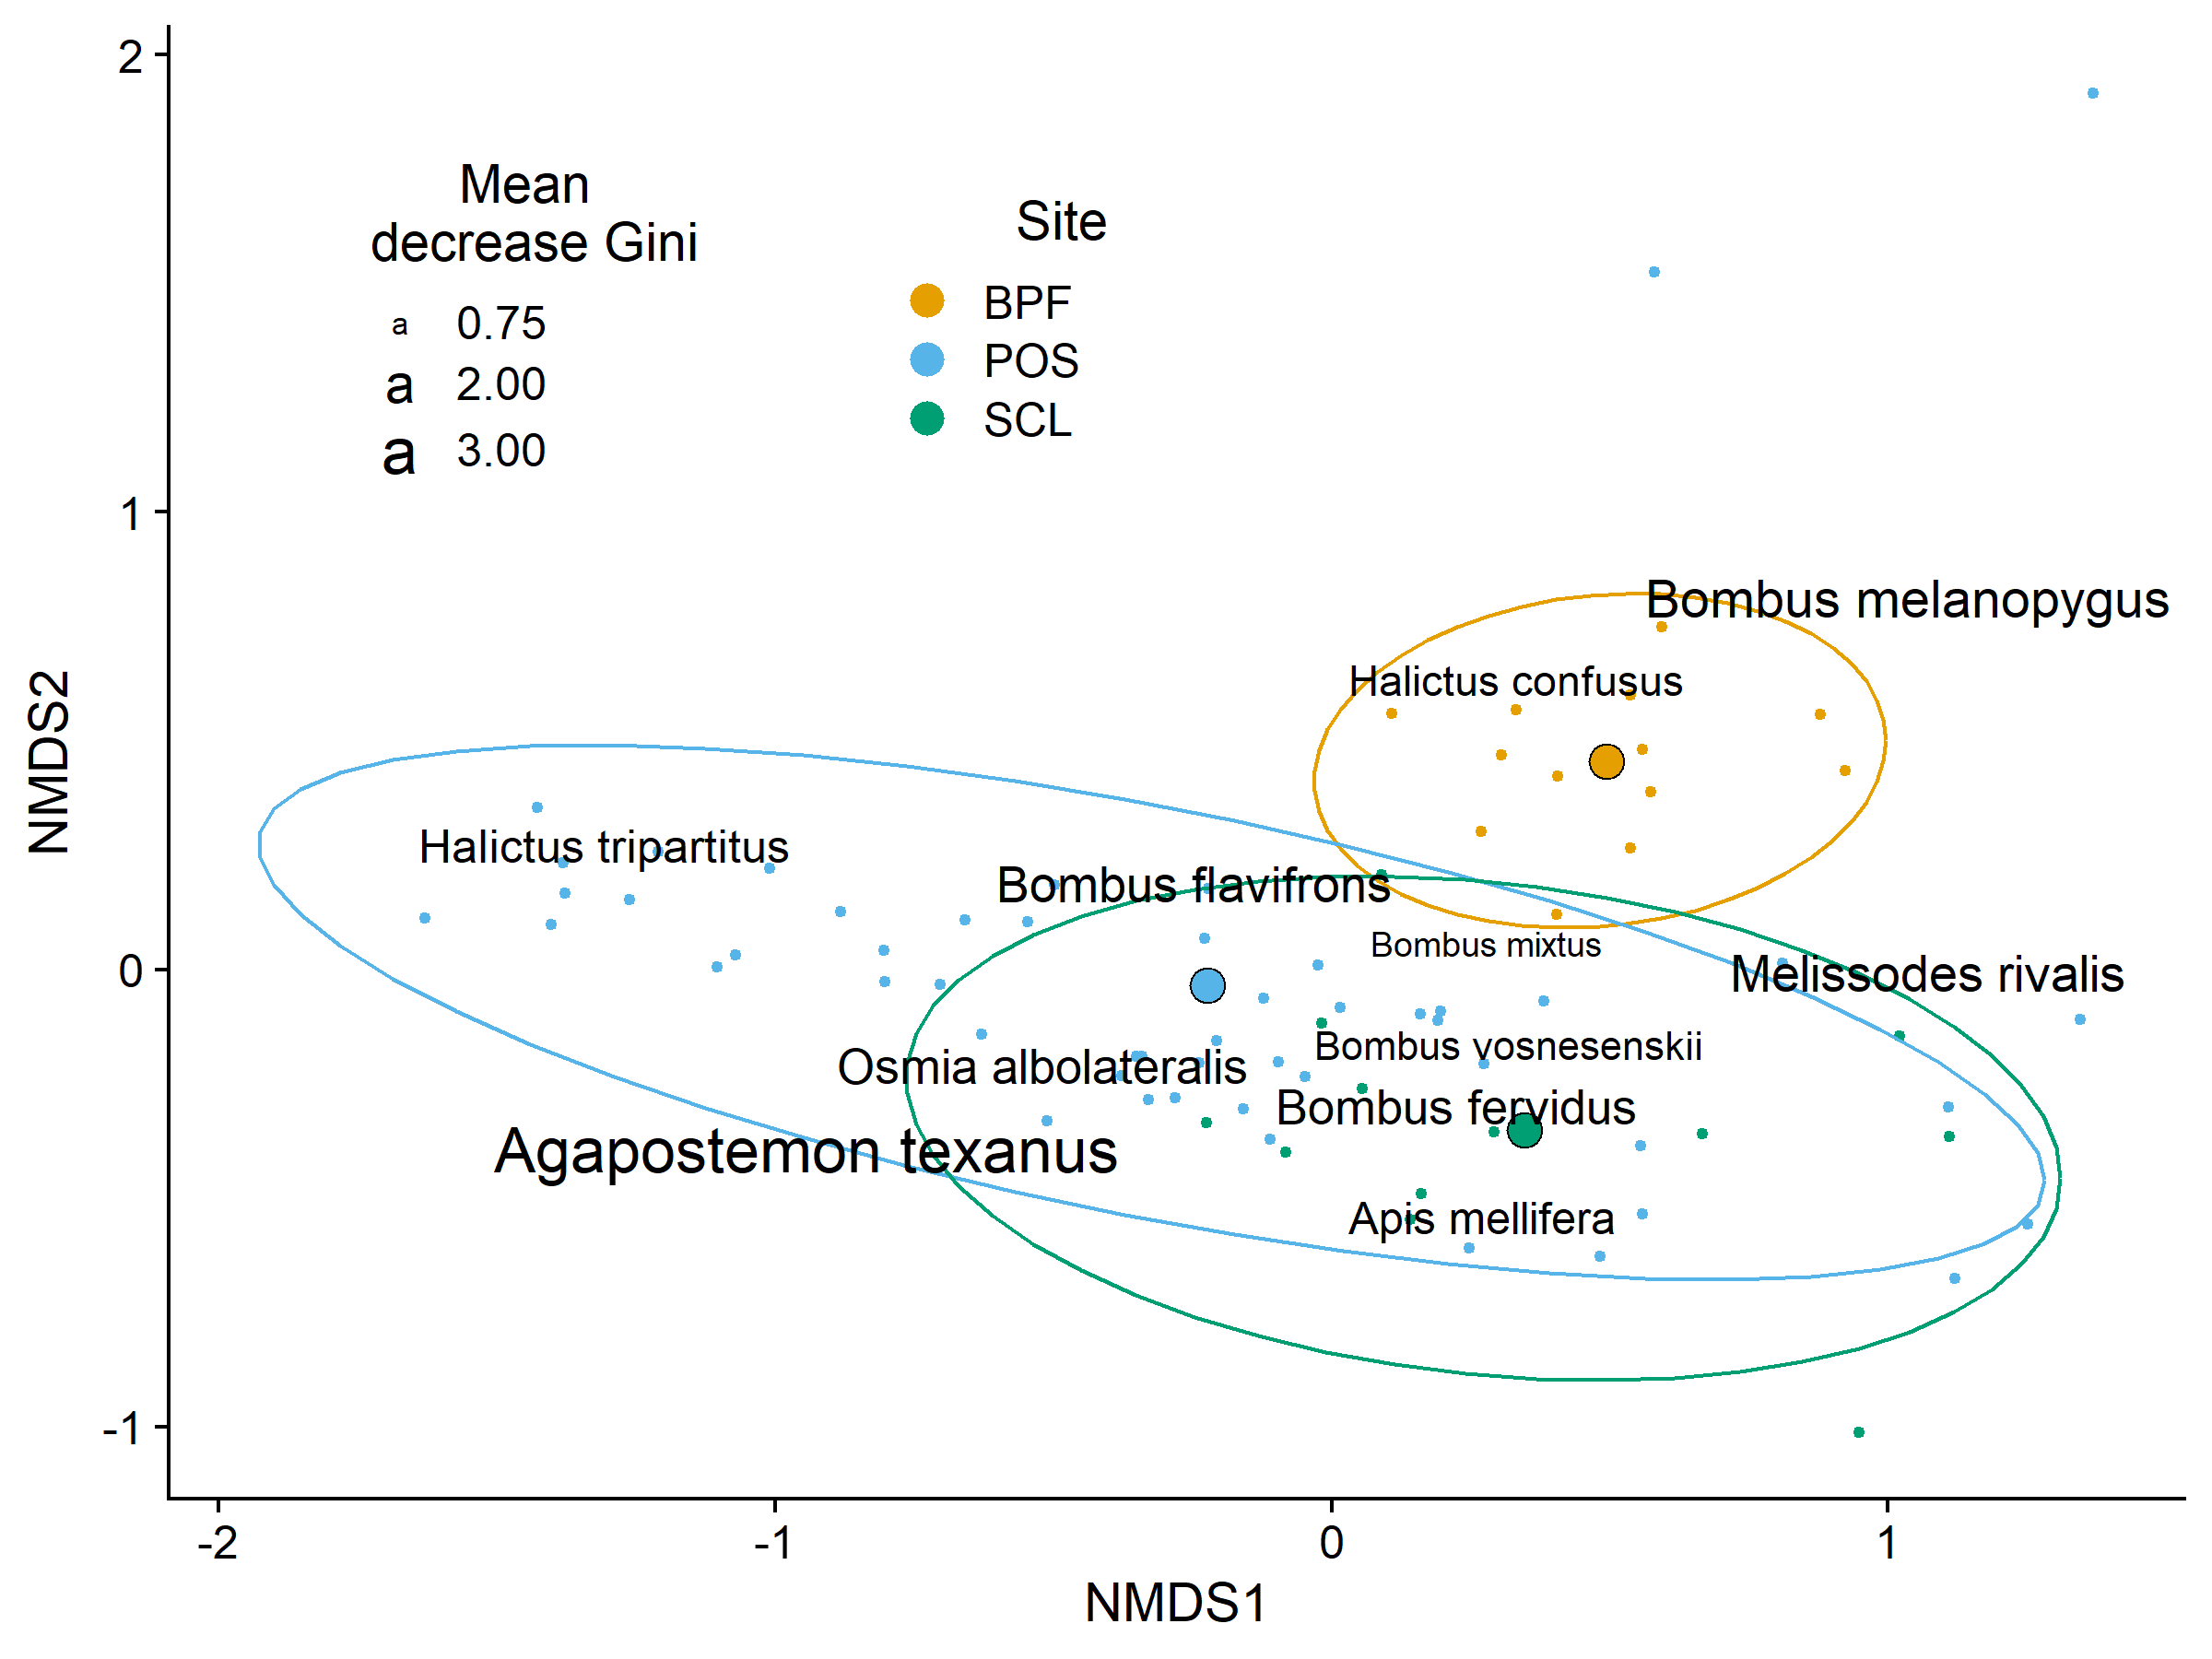

**Fig. 4**

**Fig. 5**

**Fig. 6**

**Table S1.** Species found only once across all sampling and the site at which they were found.

|  |  |
| --- | --- |
| **Species** | **Site** |
| *Agapostemon femoratus* | Port of Seattle |
| *Andrena buckelli* | Seattle City Light |
| *Andrena gordoni* | Port of Seattle |
| *Andrena hippotes* | Seattle City Light |
| *Andrena miranda* | Port of Seattle |
| *Andrena subaustralis* | Port of Seattle |
| *Andrena subtilis* | Port of Seattle |
| *Andrena transnigra* | Seattle City Light |
| *Colletes kincaidii* | Port of Seattle |
| *Coelioxys gilensis* | Port of Seattle |
| *Lasioglossum nigroviride* | Boeing Point Field |
| *Lasioglossum ovaliceps* | Seattle City Light |
| *Lasioglossum punctatoventre* | Port of Seattle |
| *Lasioglossum sedi* | Port of Seattle |
| *Lasioglossum yukonae* | Seattle City Light |
| *Megachile fidelis* | Port of Seattle |
| *Megachile gravita* | Port of Seattle |
| *Megachile onobrychidis* | Port of Seattle |
| *Nomada formula* | Port of Seattle |
| *Osmia densa* | Seattle City Light |
|  |  |
|  |  |
|  |  |
|  |  |
|  |  |
|  |  |
|  |  |
|  |  |
|  |  |

**Table S2.** The top 10 most abundant species across all sampling.

|  |  |
| --- | --- |
| **Species** | **Records** |
| *Halictus tripartitus* | 11,787 |
| *Agapostemon texanus* | 2,568 |
| *Bombus vosnesenskii* | 2,148 |
| *Halictus rubicundus* | 1,047 |
| *Ceratina acantha* | 867 |
| *Bombus flavifrons* | 782 |
| *Bombus mixtus* | 619 |
| *Apis mellifera* | 575 |
| *Melissodes microsticta* | 538 |
| *Lasioglossum villosulum* | 484 |

**Table S3.** Species found at all three sites across the entire sample.

|  |
| --- |
| **Species** |
| *Agapostemon texanus* |
| *Agapostemon virescens* |
| *Andrena angustitarsata* |
| *Andrena candida* |
| *Andrena nigrihirta* |
| *Andrena prunorum* |
| *Andrena salicifloris* |
| *Anthidium manicatum* |
| *Apis mellifera* |
| *Bombus fervidus* |
| *Bombus flavifrons* |
| *Bombus melanopygus* |
| *Bombus mixtus* |
| *Bombus sitkensis* |
| *Bombus vosnesenskii* |
| *Ceratina acantha* |
| *Ceratina nanula* |
| *Coelioxys rufitarsis* |
| *Colletes fulgidus* |
| *Halictus confusus* |
| *Halictus rubicundus* |
| *Halictus tripartitus* |
| *Hoplitis producta* |
| *Hylaeus modestus* |
| *Lasioglossum aff. tenax* |
| *Lasioglossum buccale* |
| *Lasioglossum cooleyi* |
| *Lasioglossum cressonii* |
| *Lasioglossum incompletum* |
| *Lasioglossum kincaidii* |
| *Lasioglossum knereri* |
| *Lasioglossum laevissimum* |
| *Lasioglossum nevadense* |
| *Lasioglossum pacatum* |
| *Lasioglossum pacificum* |
| *Lasioglossum ruidosense* |
| *Lasioglossum villosulum* |
| *Lasioglossum zonulum* |
| *Megachile melanophaea* |
| *Megachile montivaga* |
| *Megachile perihirta* |
| *Melissodes microsticta* |
| *Melissodes rivalis* |
| *Osmia albolateralis* |
| *Osmia dolerosa* |
| *Osmia giliarum* |
| *Osmia lignaria* |
| *Osmia proxima* |
| *Osmia pusilla* |
| *Osmia trifoliama* |
| *Osmia tristella* |

**Table S4.** Species collected only by net.

|  |
| --- |
| **Species** |
| *Andrena vicuña* |
| *Andrena pallidifovea* |
| *Lasioglossum titusi* |
| *Andrena subtilis* |
| *Andrena scurra* |
| *Andrena gordoni* |
| *Andrena piperi* |
| *Lasioglossum punctatoventre* |
| *Lasioglossum sedi* |
| *Megachile fidelis* |
| *Coelioxys gilensis* |

**Table S5.** Species for which no males were collected by either traps or netting.

|  |  |  |
| --- | --- | --- |
| **Species** | **Female** | **Male** |
| *Agapostemon femoratus* | 1 | 0 |
| *Andrena crataegi* | 2 | 0 |
| *Andrena gordoni* | 1 | 0 |
| *Andrena hippotes* | 1 | 0 |
| *Andrena knuthiana* | 5 | 0 |
| *Andrena miranda* | 1 | 0 |
| *Andrena nigrocaerulea* | 5 | 0 |
| *Andrena pallidifovea* | 5 | 0 |
| *Andrena piperi* | 6 | 0 |
| *Andrena subtilis* | 1 | 0 |
| *Andrena thaspii* | 4 | 0 |
| *Bombus rufocinctus* | 2 | 0 |
| *Coelioxys gilensis* | 1 | 0 |
| *Coelioxys octodentata* | 3 | 0 |
| *Diadasia enavata* | 2 | 0 |
| *Halictus tripartitus* | 11,787 | 0 |
| *Hoplitis albifrons* | 6 | 0 |
| *Hylaeus punctatus* | 4 | 0 |
| *Lasioglossum cordleyi* | 3 | 0 |
| *Lasioglossum kincaidii* | 31 | 0 |
| *Lasioglossum ovaliceps* | 1 | 0 |
| *Lasioglossum pacatum* | 52 | 0 |
| *Lasioglossum punctatoventre* | 1 | 0 |
| *Lasioglossum ruidosense* | 6 | 0 |
| *Lasioglossum sedi* | 1 | 0 |
| *Lasioglossum titusi* | 2 | 0 |
| *Lasioglossum yukonae* | 1 | 0 |
| *Lasioglossum zephyrum* | 7 | 0 |
| *Megachile fidelis* | 1 | 0 |
| *Megachile onobrychidis* | 1 | 0 |
| *Nomada formula* | 1 | 0 |
| *Osmia densa* | 1 | 0 |
| *Osmia phaceliae* | 3 | 0 |
| *Osmia texana* | 3 | 0 |

**Table S6.** Representation of *Apis mellifera* across all sites combined, and the individual sites.

|  |  |  |  |
| --- | --- | --- | --- |
| **Site** | ***Apis mellifera*** | **Total** | **Percent** |
| All sites | 575 | 25,441 | 2.26 |
| Boeing Point Field | 8 | 1,854 | 0.43 |
| Port of Seattle | 444 | 21,691 | 2.05 |
| Seattle City Light | 123 | 1,896 | 6.49 |

**Fig. S1.** Estimated genus-level seasonal distributions for parasites: (A) *Stelis*, (B) *Epeolus*, and (C) *Triepeolus*. Beneath each parasite genera are presumed host genera. Sample sizes on the right are the total records for each genus. Vertical dashed lines are 21 March, 21 June, and 21 September. These parasites have low sample sizes limiting accurate estimation.

